Contact Information Below

CoreLogic® Reports More Than 860,000 Completed Foreclosures Nationally in the Last Twelve Months

––145,000 Y-O-Y Decline in Foreclosure Inventory to 1.4 Million Homes––
SANTA ANA, Calif., March 15, 2012—CoreLogic (NYSE: CLGX), a leading provider of information, analytics and business services, today released its National Foreclosure Report for January, which provides monthly data on completed foreclosures, foreclosure inventory and 90+ delinquency rates. There were 69,000 completed foreclosures in January 2012, compared to 80,000 in January 2011, and 65,000 in December 2011. The number of completed foreclosures for the previous twelve months was 860,128. From the start of the financial crisis in September 2008, there have been approximately 3.3 million completed foreclosures.

“We are encouraged by the noticeable progress we are seeing over the last several months in the mortgage industry,” said Anand Nallathambi, chief executive officer of CoreLogic. “During the last several years the industry has faced enormous challenges working through difficult and complex issues. We are hopeful that these recent improvements are early signals of revitalization in the mortgage market.”

Approximately 1.4 million homes, or 3.3 percent of all homes with a mortgage, were in the foreclosure inventory as of January 2012 compared to 1.5 million, or 3.6 percent, in January 2011 and 1.4 million, or 3.4 percent, in December 2011. Nationally, the number of loans in the foreclosure inventory decreased by 145,000, or 9.5 percent in January 2012 compared to January 2011. The foreclosure inventory is the stock of homes in the foreclosure process. A property moves into the foreclosure inventory when the mortgage servicer places the property into the foreclosure process after serious delinquency is reached and remains there until the foreclosure is completed. The foreclosure inventory is measured only against homes with an outstanding mortgage, rather than against all homes. Nationwide, roughly one third of homeowners own their homes outright.

The share of borrowers nationally that were more than 90 days late on their mortgage payment, including homes in foreclosure and REO, fell to 7.2 percent in January 2012 from 7.8 percent in January 2011, but remained unchanged from December 2011.

The inventory of REO assets held by servicers nationwide grew faster in January than the pace of REO sales, as measured by the distressed clearing ratio. The distressed clearing ratio is calculated by dividing the number of REO sales by the number of completed foreclosures; the higher the ratio, the faster the pace of REO sales relative to the pace of completed foreclosures. The distressed clearing ratio for January 2012 was 0.69, down from 0.80 in December 2011.

“The pace of completed foreclosures is gradually increasing again, but the clearing ratio is falling as REO sales have slowed in the winter months. Judicial foreclosure states¹ are continuing to process foreclosures more slowly than non-judicial foreclosure states,” said Mark Fleming, chief economist with CoreLogic. “Non-judicial foreclosure states completed almost twice as many foreclosures per 1000 active loans as judicial foreclosure states in January.”

Highlights as of January 2012
  - The five states with the largest number of completed foreclosures for the twelve months ending in January 2012 were: California (155,000), Florida (86,000), Arizona (65,000), Michigan (65,000) and Texas (57,000). These five states account for 49.7 percent of all completed foreclosures nationally.
  - The percent of homeowners nationally who were more than 90 days late on their mortgage payments, including homes in foreclosure and REO, was 7.2 percent for January 2012 compared to 7.8 percent for January 2011, and 7.2 percent in December 2011.
  - The five states with the highest foreclosure rates were: Florida (11.8 percent), New Jersey (6.4 percent), Illinois (5.3 percent), Nevada (5.0 percent) and New York (4.7 percent).
  - The five states with the lowest foreclosure rates were: Wyoming (0.7 percent), Alaska (0.8 percent), North Dakota (0.8 percent), Nebraska (1.1 percent) and Texas (1.3 percent).
  - Of the top 100 markets, measured by Core Based Statistical Areas (CBSAs) population, 32 are showing an increase in the foreclosure rate in January 2012 compared to a year ago, the same as from December 2011 when 32* of the top CBSAs were showing an increase in the foreclosure rate compared to December 2010.

*December data was revised. Revisions are standard, and to ensure accuracy CoreLogic incorporates newly released data to provide updated results.

Judicial Foreclosure States Foreclosure and Delinquency Ranking (Sorted by Foreclosure Inventory):
Judicial  Foreclosure States | January-2012
 | 90+ Delinquent | 90+ Delinquent Pct. Point Change from a Year Ago | Foreclosure Inventory | Foreclosure Inventory Pct. Point Change from a Year Ago | Completed Foreclosures (12 months ending Jan 2012)
National | 7.2% | -0.6% | 3.3% | -0.3% | 860,128  85,764  1,626  20,813  751  2,828  1,214  8,230  12,505  26,859  1,725  2,880  3,470  11,973  8,655  9,310  N/A  12,553  4,684  3,621  33  2,762  524  69,442
FL | 17.4% | -1.0% | 11.8% | -0.5% | 85,764
NJ | 10.7% | 1.2% | 6.4% | 0.4% | 1,626
IL | 9.2% | 0.3% | 5.3% | 0.4% | 20,813
ME | 7.0% | 0.5% | 4.3% | 0.4% | 751
CT | 7.3% | 0.4% | 4.2% | 0.8% | 2,828
HI | 6.6% | -0.1% | 3.8% | 0.3% | 1,214
SC | 6.7% | 0.0% | 3.7% | 0.6% | 8,230
IN | 6.7% | 0.0% | 3.5% | 0.0% | 12,505
OH | 7.0% | 0.0% | 3.5% | -0.1% | 26,859
NM | 5.7% | 0.2% | 3.3% | 0.4% | 1,725
DE | 6.8% | 0.2% | 3.1% | -0.3% | 2,880
MD | 8.1% | 0.0% | 3.1% | 0.4% | 3,470
PA | 5.9% | 0.2% | 2.7% | 0.1% | 11,973
OK | 5.3% | 0.2% | 2.5% | -0.1% | 8,655
LA | 6.4% | -0.4% | 2.5% | -0.5% | 9,310
VT | 4.0% | 0.4% | 2.4% | 0.3% | N/A
WI | 4.6% | -0.2% | 2.2% | -0.2% | 12,553
IA | 4.2% | -0.1% | 2.1% | -0.2% | 4,684
KS | 4.5% | 0.0% | 1.7% | -0.2% | 3,621
SD | 2.7% | -0.1% | 1.3% | 0.0% | 33
NE | 3.0% | -0.2% | 1.1% | -0.1% | 2,762
ND | 1.7% | 0.0% | 0.8% | -0.1% | 524
Source: CoreLogic Jan 2012

Non-Judicial Foreclosure States Foreclosure and Delinquency Ranking (Sorted by Foreclosure Inventory):
Non-Judicial Foreclosure States | January-2012
 | 90+ Delinquent | 90+ Delinquent Pct. Point Change from a Year Ago | Foreclosure Inventory | Foreclosure Inventory Pct. Point Change from a Year Ago | Completed Foreclosures (12 months ending Jan 2012)
NV | 13.3% | -3.4% | 5.0% | -3.2% | 37,503
NY | 8.0% | 0.4% | 4.7% | 0.5% | 3,427
KY | 5.7% | 0.2% | 2.8% | 0.2% | 2,401
OR | 5.5% | -0.2% | 2.8% | 0.2% | 10,256
MS | 7.8% | -0.1% | 2.7% | 0.1% | 961
AZ | 7.0% | -3.1% | 2.6% | -1.6% | 65,015
DC | 5.7% | 0.1% | 2.5% | 0.2% | 204
CA | 6.9% | -2.3% | 2.5% | -0.7% | 155,107
NC | 5.9% | 0.3% | 2.5% | 0.3% | 22,748
RI | 7.6% | -0.3% | 2.4% | -1.0% | 3,472
GA | 8.0% | -0.7% | 2.3% | -0.4% | 56,454
ID | 5.1% | -0.9% | 2.1% | -0.6% | 7,989
MI | 6.3% | -1.3% | 2.0% | -0.8% | 64,902
MA | 5.7% | -0.2% | 2.0% | -0.2% | 9,375
TN | 6.3% | -0.1% | 1.9% | -0.2% | 24,730
UT | 5.1% | -0.8% | 1.8% | -0.5% | 8,373
MN | 4.5% | -0.7% | 1.7% | -0.4% | 13,998
NH | 4.6% | -0.3% | 1.7% | -0.1% | 2,904
AR | 5.5% | 0.4% | 1.5% | -0.3% | 3,866
VA | 4.1% | -0.5% | 1.5% | -0.1% | 16,639
WV | 4.1% | -0.5% | 1.4% | -0.3% | 574
MO | 4.7% | -0.2% | 1.4% | -0.1% | 17,199
CO | 4.1% | -0.6% | 1.4% | -0.5% | 20,813
WA | 6.3% | 0.2% | 1.4% | -0.8% | 21,244
MT | 3.1% | -0.4% | 1.3% | -0.3% | 1,814
AL | 5.8% | -0.2% | 1.3% | -0.4% | 6,888
TX | 4.9% | -0.2% | 1.3% | -0.2% | 56,801
AK | 2.3% | -0.2% | 0.8% | -0.2% | 919
WY | 2.5% | -0.4% | 0.7% | -0.4% | 771
Source: CoreLogic Jan 2012

Foreclosure and Delinquency Levels for Select Large Core Based Statistical Areas (CBSAs):
CBSA | January-2012
 | 90+ Delinquent | 90+ Delinquent Pct. Point Change from a Year Ago | Foreclosure Inventory | Foreclosure Inventory Pct. Point Change from a Year Ago | Completed Foreclosures (12 months ending Jan 2012)
Chicago-Joliet-Naperville, IL | 10.7% | 0.3% | 6.2% | 0.4% | 15,172
Los Angeles-Long Beach-Glendale, CA | 7.1% | -2.2% | 2.5% | -0.7% | 26,517
Atlanta-Sandy Springs-Marietta, GA | 8.9% | -1.0% | 2.6% | -0.5% | 39,365
New York-White Plains-Wayne, NY-NJ | 8.7% | 0.1% | 5.4% | 0.3% | 775
Washington-Arlington-Alexandria, DC-VA-MD-WV | 5.8% | -0.8% | 2.3% | -0.1% | 7,077
Houston-Sugar Land-Baytown, TX | 5.3% | -0.4% | 1.5% | -0.2% | 16,469
Phoenix-Mesa-Glendale, AZ | 7.4% | -4.0% | 2.8% | -2.0% | 50,545
Riverside-San Bernardino-Ontario, CA | 9.8% | -3.9% | 3.5% | -1.3% | 31,415
Dallas-Plano-Irving, TX | 5.2% | -0.2% | 1.4% | -0.2% | 11,657
Minneapolis-St. Paul-Bloomington, MN-WI | 4.9% | -0.8% | 1.9% | -0.4% | 12,277
Philadelphia, PA | 5.8% | 0.3% | 2.5% | 0.1% | 3,856
Seattle-Bellevue-Everett, WA | 6.4% | 0.0% | 1.4% | -0.9% | 8,874
Denver-Aurora-Broomfield, CO | 4.2% | -0.7% | 1.4% | -0.5% | 10,705
San Diego-Carlsbad-San Marcos, CA | 5.8% | -1.9% | 2.1% | -0.4% | 10,042
Tampa-St. Petersburg-Clearwater, FL | 17.1% | -0.1% | 12.1% | 0.5% | 10,113
Santa Ana-Anaheim-Irvine, CA | 5.3% | -1.5% | 2.0% | -0.3% | 6,816
St. Louis, MO-IL | 5.0% | -0.1% | 1.7% | -0.1% | 9,118
Baltimore-Towson, MD | 7.7% | 0.4% | 2.9% | 0.5% | 1,478
Oakland-Fremont-Hayward, CA | 6.3% | -2.3% | 2.3% | -0.6% | 11,542
Nassau-Suffolk, NY | 10.4% | 0.3% | 6.4% | 0.7% | 650
Warren-Troy-Farmington Hills, MI | 5.8% | -1.7% | 1.9% | -1.0% | 15,569
Portland-Vancouver-Hillsboro, OR-WA | 5.5% | -0.2% | 2.3% | 0.0% | 6,151
Sacramento--Arden-Arcade--Roseville, CA | 7.4% | -2.6% | 2.7% | -0.7% | 15,446
Edison-New Brunswick, NJ | 8.8% | 1.0% | 5.3% | 0.4% | 453
Orlando-Kissimmee-Sanford, FL | 18.2% | -1.4% | 12.0% | -0.6% | 10,082
Source: CoreLogic Jan 2012

Figure 1 - Completed Foreclosures per Thousand Active Loans
Judicial Foreclosure States vs. Non-Judicial Foreclosure States (3mo moving avg)
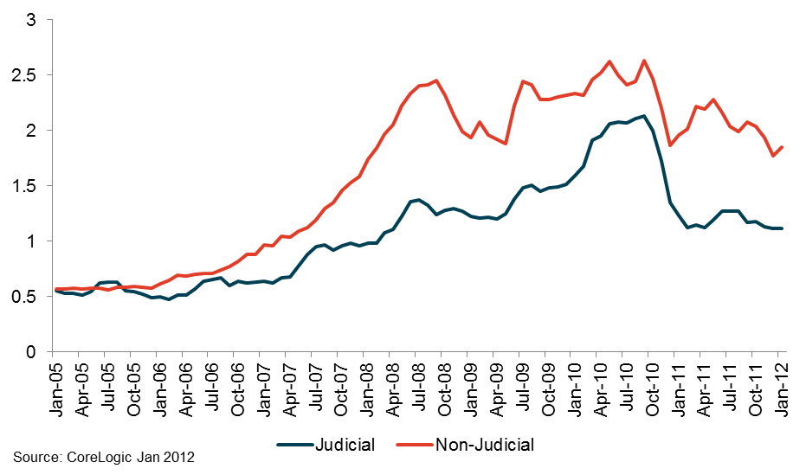

Figure 2 – Foreclosure Rates as of January 2012
Judicial Foreclosure States vs. Non-Judicial Foreclosure States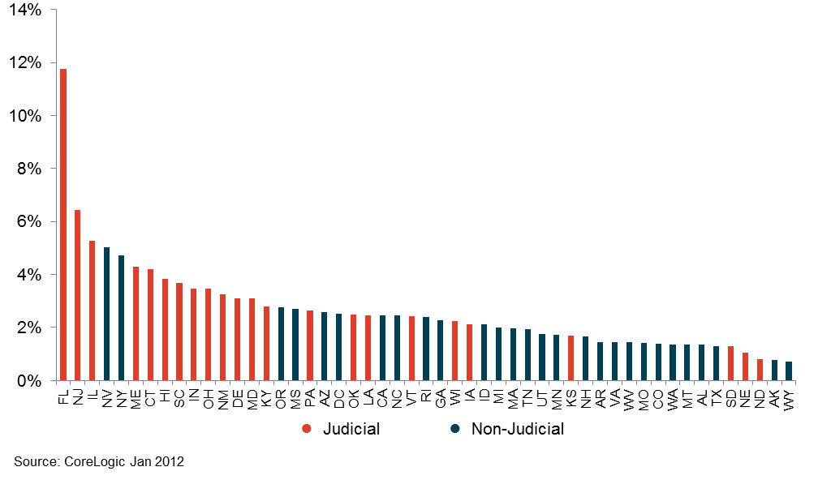

Figure 3 – CoreLogic Serious Delinquency Rates
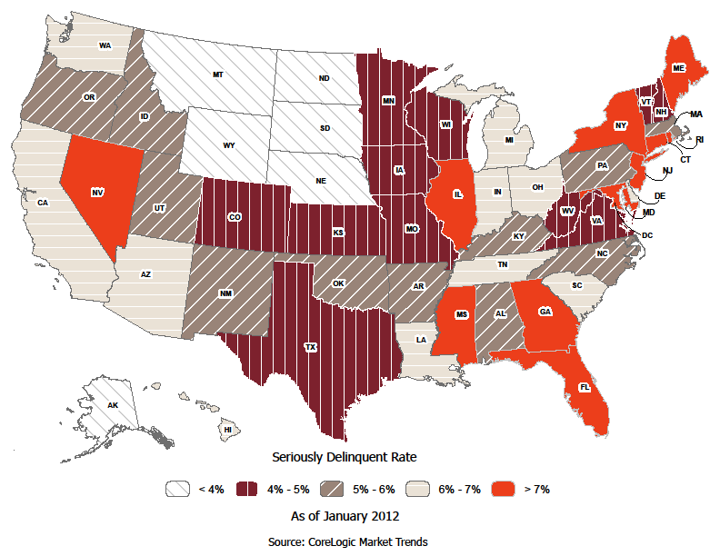
Methodology
¹This report has state data separated into judicial vs. non-judicial foreclosure state categories. In judicial foreclosure states, lenders must provide evidence to the courts of delinquency in order to move a borrower into foreclosure, while in non-judicial foreclosure states lenders can issue notices of default directly to the borrower without court intervention. It’s important to distinguish this since judicial states as a rule have longer foreclosure timelines and thus affect foreclosure statistics as a result.

A completed foreclosure occurs when a property is auctioned and results in the purchase of the home at auction by either a third party, such as an investor, or by the lender. If the home is purchased by the lender, it is moved into the lender’s Real Estate Owned (REO) inventory. In “foreclosure by advertisement” states, a redemption period begins after the auction and runs for a statutory period, e.g., six months. During that period the borrower may regain the foreclosed home by paying all amounts due as calculated under the statute. For purposes of this Foreclosure Report, because so few homes are actually redeemed following an auction, we assume the foreclosure process ends in “foreclosure by advertisement” states at the completion of the auction. The foreclosure inventory represents the number and ratio of homes that have been placed into the process of foreclosure by the mortgage servicer. Mortgage servicers start the foreclosure process when the mortgage reaches a specific level of serious delinquency as dictated by the investor for the mortgage loan. Serious delinquency is typically defined as 90, 120, or 150 days delinquent (sometimes more), in foreclosure or in REO. Once a foreclosure is “started,” and absent the borrower paying all amounts necessary to halt the foreclosure, the home remains in foreclosure until the completed foreclosure results in the sale to a third party at auction or the home enters the lender’s REO inventory. The foreclosure inventory is measured only against homes that have an outstanding mortgage. Homes with no mortgage liens can never be in foreclosure and are therefore excluded from the analysis. Approximately one-third of homes nationally are owned outright and do not have a mortgage. CoreLogic has approximately 85 percent coverage of U.S. foreclosure data. The distressed clearing ratio is calculated by dividing the number of REO sales by completed foreclosures. It is a measure of whether the REO inventory is growing or shrinking. The higher the ratio, the faster the REO inventory is clearing.

About CoreLogic
CoreLogic (NYSE: CLGX) is a leading provider of consumer, financial and property information, analytics and services to business and government. The Company combines public, contributory and proprietary data to develop predictive decision analytics and provide business services that bring dynamic insight and transparency to the markets it serves. CoreLogic has built one of the largest and most comprehensive U.S. real estate, mortgage application, fraud, and loan performance databases and is a recognized leading provider of mortgage and automotive credit reporting, property tax, valuation, flood determination, and geospatial analytics and services. More than one million users rely on CoreLogic to assess risk, support underwriting, investment and marketing decisions, prevent fraud, and improve business performance in their daily operations. The Company, headquartered in Santa Ana, Calif., has more than 5,000 employees globally. For more information, visit www.corelogic.com.

Source: CoreLogic
The data provided is for use only by the primary recipient or the primary recipient's publication or broadcast. This data may not be re-sold, republished or licensed to any other source, including publications and sources owned by the primary recipient's parent company without prior written permission from CoreLogic. Any CoreLogic data used for publication or broadcast, in whole or in part, must be sourced as coming from CoreLogic, a data and analytics company. For use with broadcast or web content, the citation must directly accompany first reference of the data. If the data is illustrated with maps, charts, graphs or other visual elements, the CoreLogic logo must be included on screen or web site. For questions, analysis or interpretation of the data, contact Lori Guyton at lguyton@cvic.com or Bill Campbell at bill@campbelllewis.com. Data provided may not be modified without the prior written permission of CoreLogic. Do not use the data in any unlawful manner. This data is compiled from public records, contributory databases and proprietary analytics, and its accuracy is dependent upon these sources.

CORELOGIC and the stylized CoreLogic logo are registered trademarks owned by CoreLogic, Inc. and/or its subsidiaries. No trademark of CoreLogic shall be used without the express written consent of CoreLogic.

For real estate industry and trade media: For general news media:
Bill Campbell Andrea Hurst
bill@campbelllewis.com ahurst@cvic.com
(212) 995.8057 (office) (405) 235.2842 (office)
(917) 328.6539 (mobile) (405) 487.7721 (mobile)

###

